Cross Sections

Definition
# Source: AI Source: Provided by: [Data Path: Persons Table -> ID Column: 1, Name_En Column: Motasem Essam] -> From: [ChatGPT] on [7/25/2026]
A Cross Section is the two-dimensional geometric figure formed by the intersection of a three-dimensional solid with a plane.
It represents the shape revealed when a solid is sliced by an imaginary or physical flat surface.
The shape of a cross-section depends on:
- The geometric shape of the solid.
- The position of the cutting plane.
- The orientation or angle of the cutting plane.
- The dimensions of the solid.
- The portion of the solid intersected by the plane.
A cross-section can be a polygon, circle, ellipse, or another two-dimensional shape.
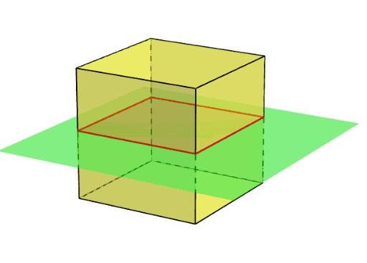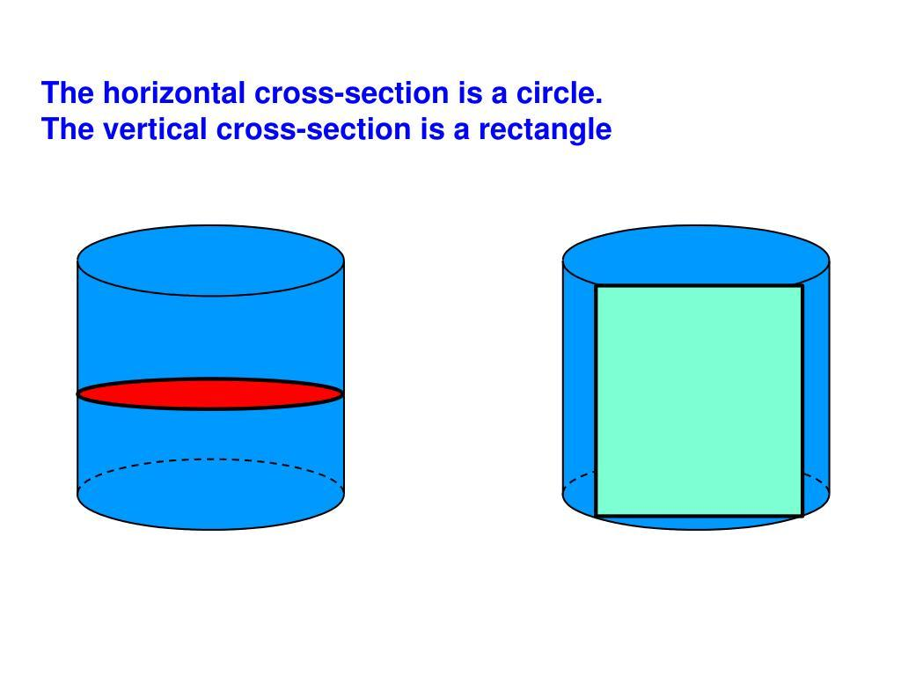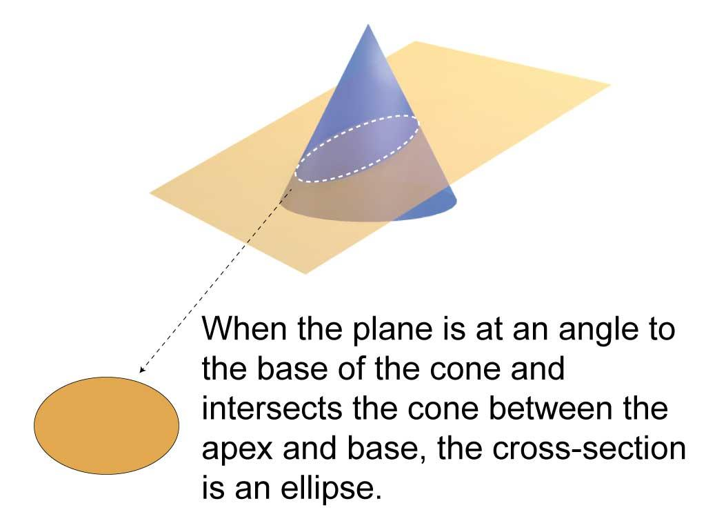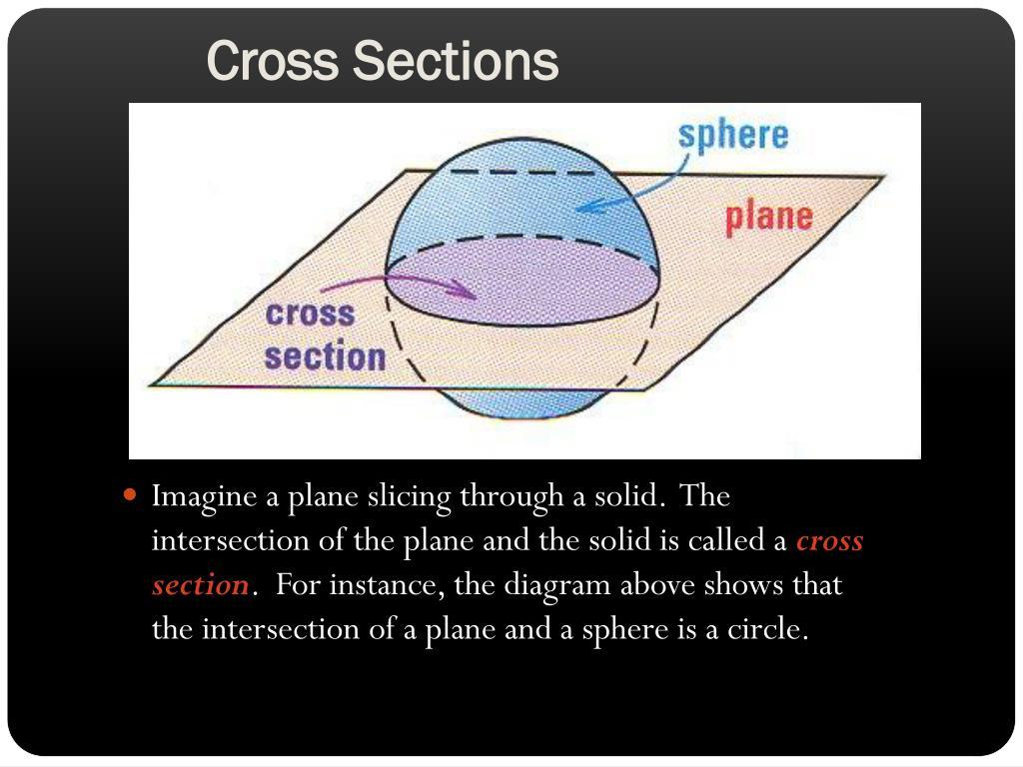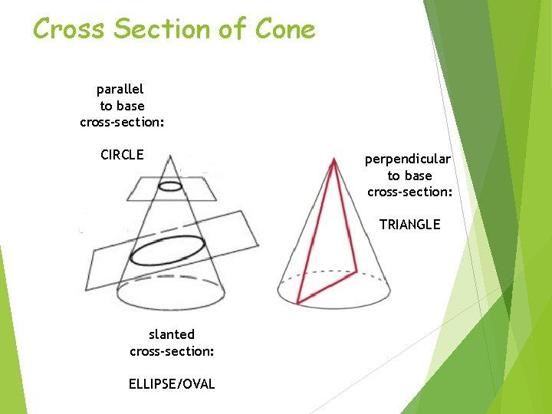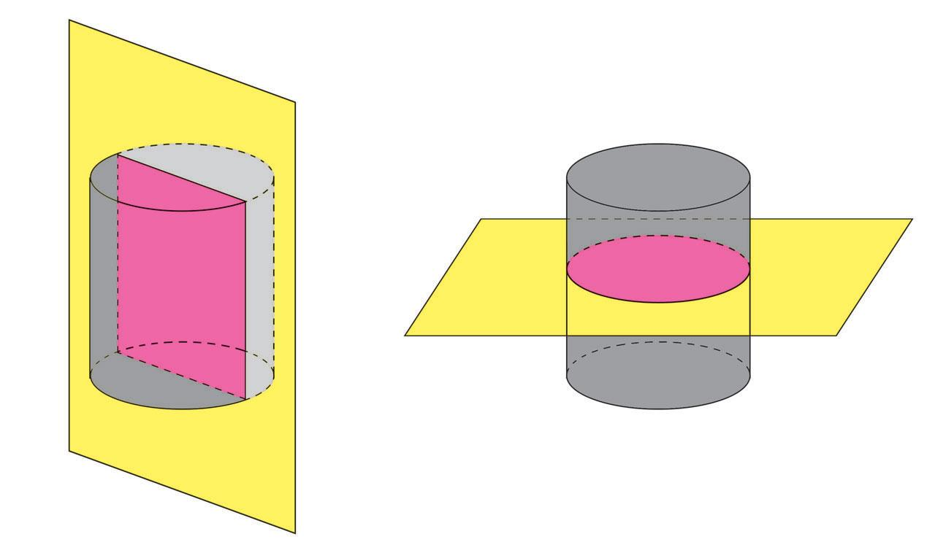

Geometric Structure
# Source: AI Source: Provided by: [Data Path: Persons Table -> ID Column: 1, Name_En Column: Motasem Essam] -> From: [ChatGPT] on [7/25/2026]
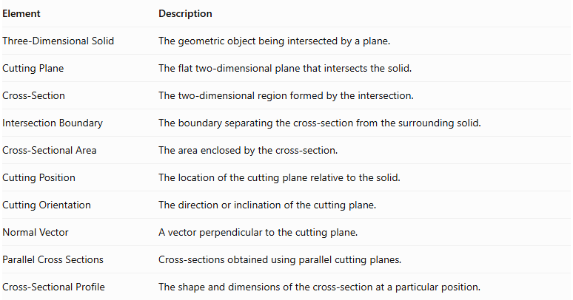
Element | Description
Three-Dimensional Solid | The geometric object being intersected by a plane.
Cutting Plane | The flat two-dimensional plane that intersects the solid.
Cross-Section | The two-dimensional region formed by the intersection.
Intersection Boundary | The boundary separating the cross-section from the surrounding solid.
Cross-Sectional Area | The area enclosed by the cross-section.
Cutting Position | The location of the cutting plane relative to the solid.
Cutting Orientation | The direction or inclination of the cutting plane.
Normal Vector | A vector perpendicular to the cutting plane.
Parallel Cross Sections | Cross-sections obtained using parallel cutting planes.
Cross-Sectional Profile | The shape and dimensions of the cross-section at a particular position.

Main Characteristics
# Source: AI Source: Provided by: [Data Path: Persons Table -> ID Column: 1, Name_En Column: Motasem Essam] -> From: [ChatGPT] on [7/25/2026]
- A cross-section is formed by intersecting a solid with a plane.
- It is generally a two-dimensional region.
- Its shape depends on the solid and the cutting plane.
- The same solid can produce different cross-sectional shapes.
- Parallel cutting planes can produce cross-sections of different sizes.
- Cross-sections of prisms parallel to their bases are congruent.
- Cross-sections of pyramids parallel to their bases are similar to the base.
- A cross-section can be used to study the internal geometry and dimensions of a solid.

Types of Cross Sections According to Plane Orientation
# Source: AI Source: Provided by: [Data Path: Persons Table -> ID Column: 1, Name_En Column: Motasem Essam] -> From: [ChatGPT] on [7/25/2026]
Cross-sections can be classified according to the orientation of the cutting plane relative to the solid's base or another reference plane.

Horizontal Cross Section
# Source: AI Source: Provided by: [Data Path: Persons Table -> ID Column: 1, Name_En Column: Motasem Essam] -> From: [ChatGPT] on [7/25/2026]
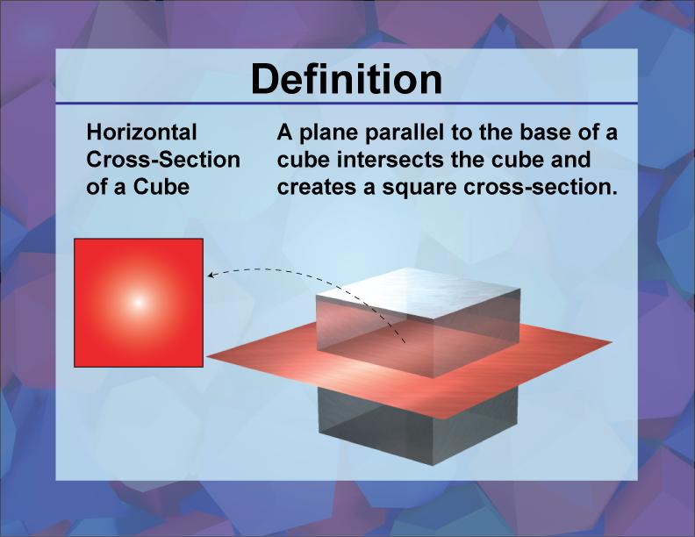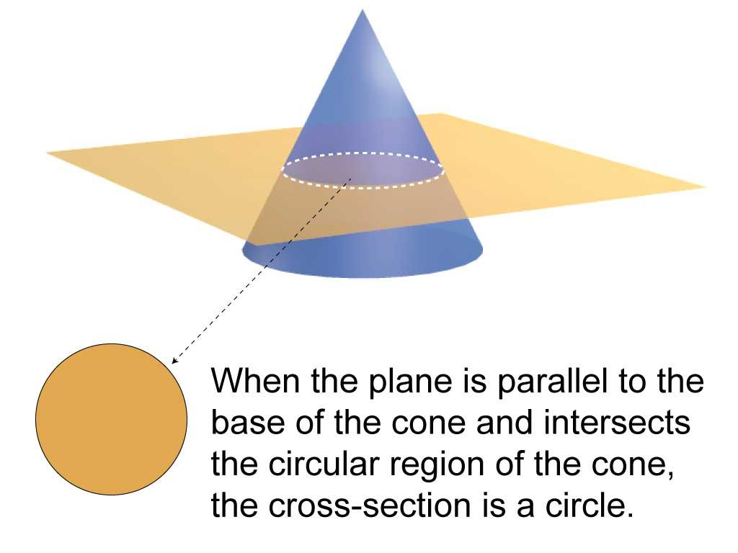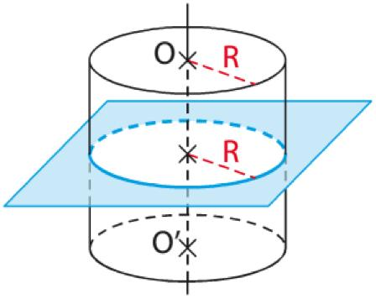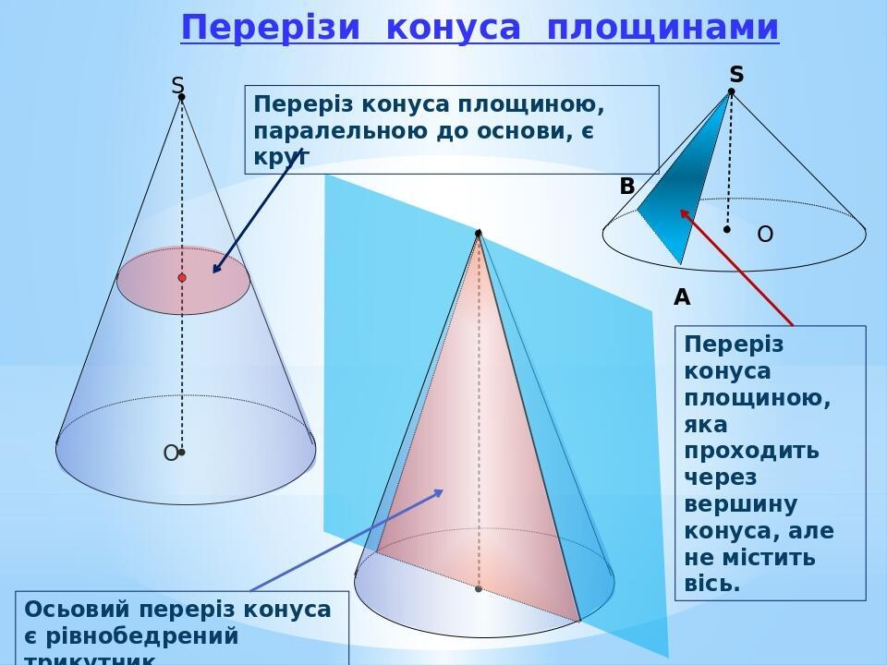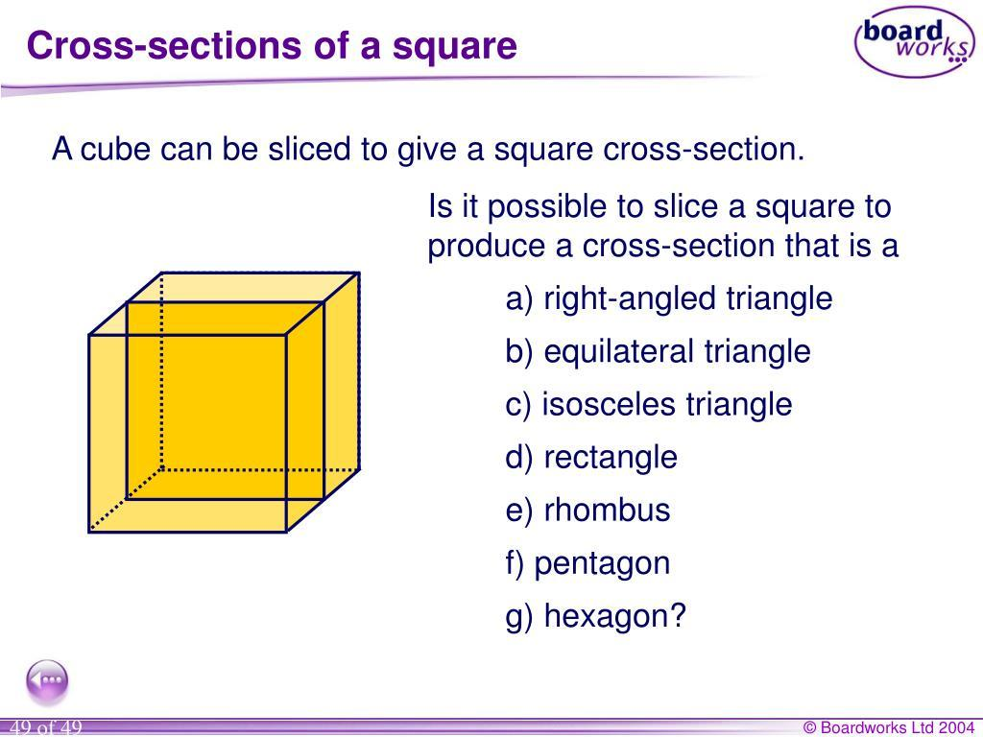
A Horizontal Cross Section is formed when a solid is intersected by a horizontal plane.
In many standard solids, this plane is parallel to the base.
Examples:
- Cube → Square.
- Rectangular Prism → Rectangle.
- Cylinder → Circle.
- Cone → Circle.
- Pyramid → Polygon similar to its base.
- Sphere → Circle, except at a tangent plane where the intersection is a point.

Vertical Cross Section
# Source: AI Source: Provided by: [Data Path: Persons Table -> ID Column: 1, Name_En Column: Motasem Essam] -> From: [ChatGPT] on [7/25/2026]
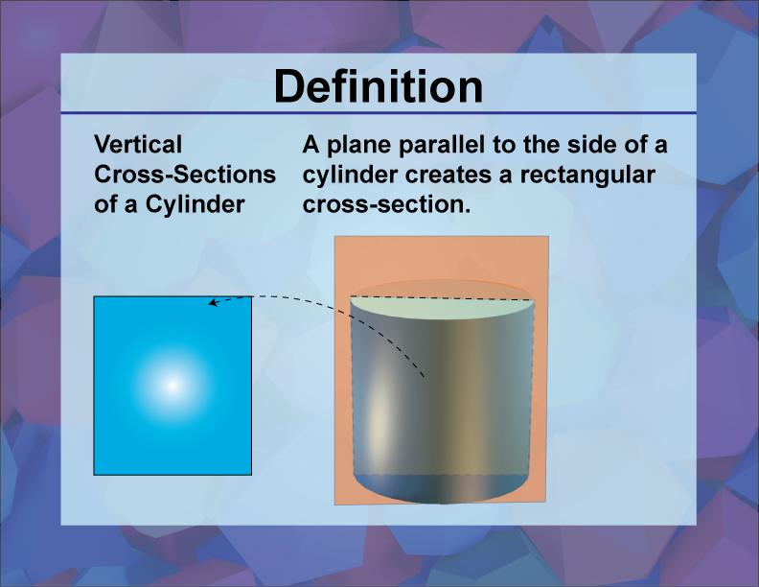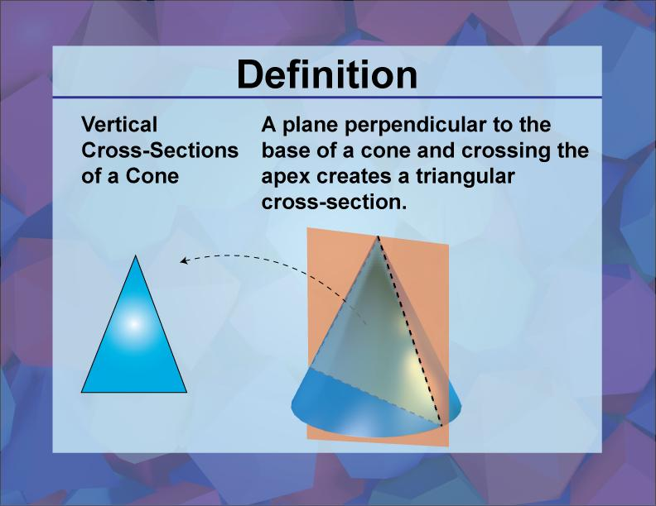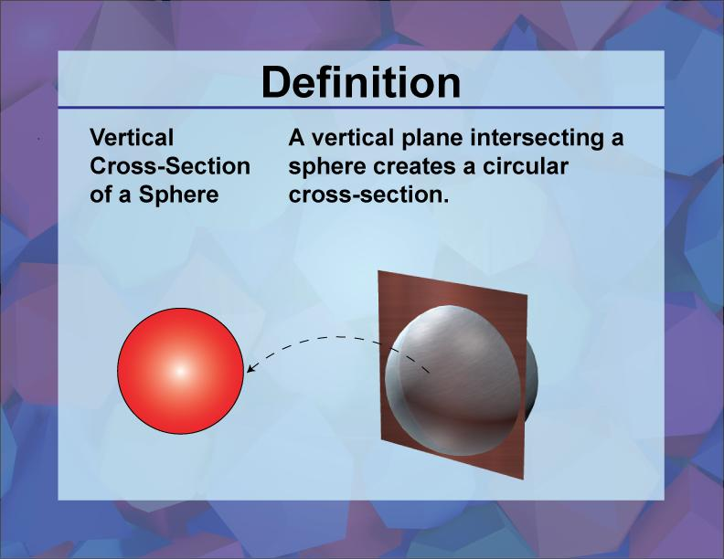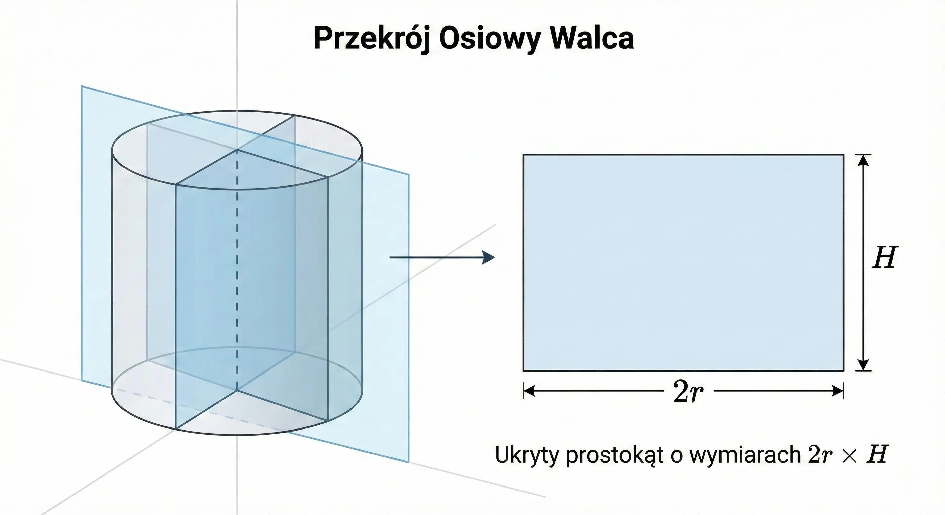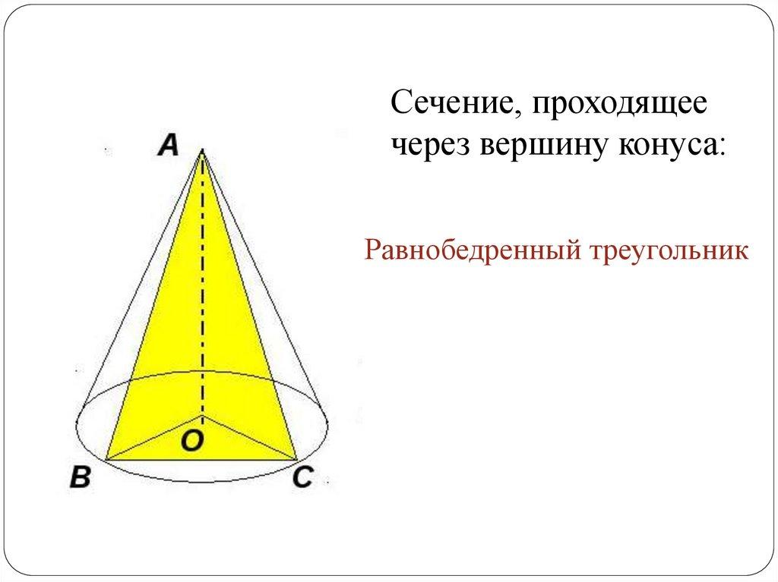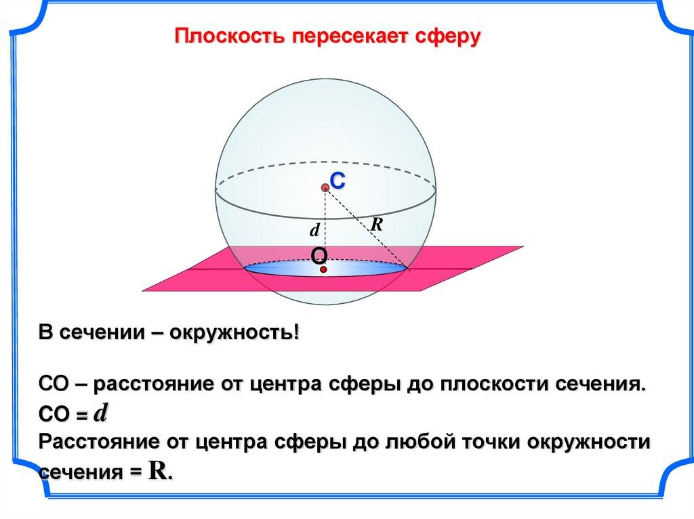
A Vertical Cross Section is formed when a solid is intersected by a vertical plane.
Examples:
- Right Circular Cylinder → Rectangle when the plane is parallel to its axis.
- Right Circular Cone → Triangle when the plane contains its axis.
- Sphere → Circle.
- Cube → Rectangle or another polygon, depending on the cutting position.

Oblique Cross Section
# Source: AI Source: Provided by: [Data Path: Persons Table -> ID Column: 1, Name_En Column: Motasem Essam] -> From: [ChatGPT] on [7/25/2026]
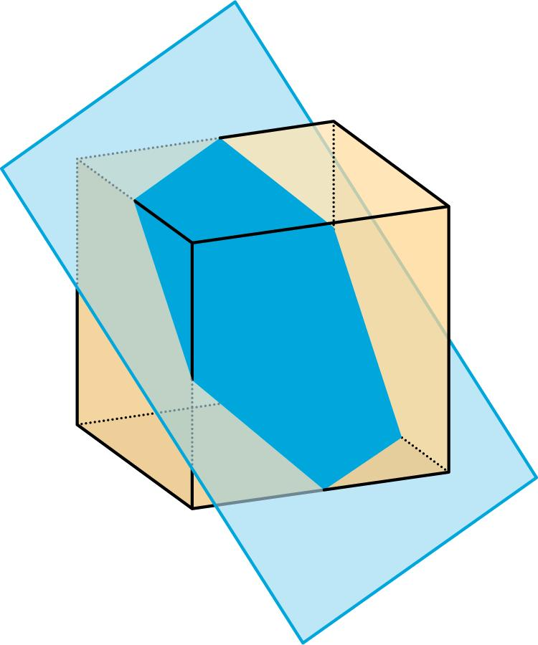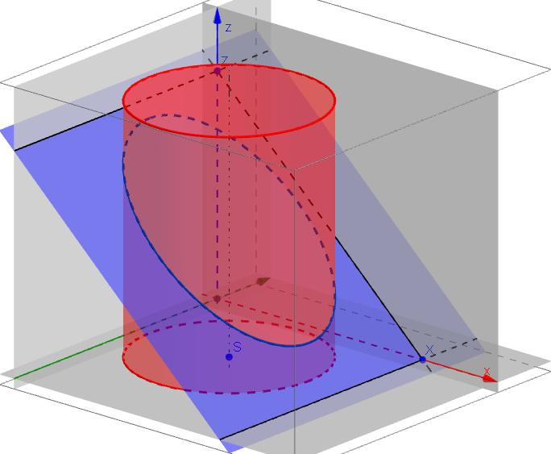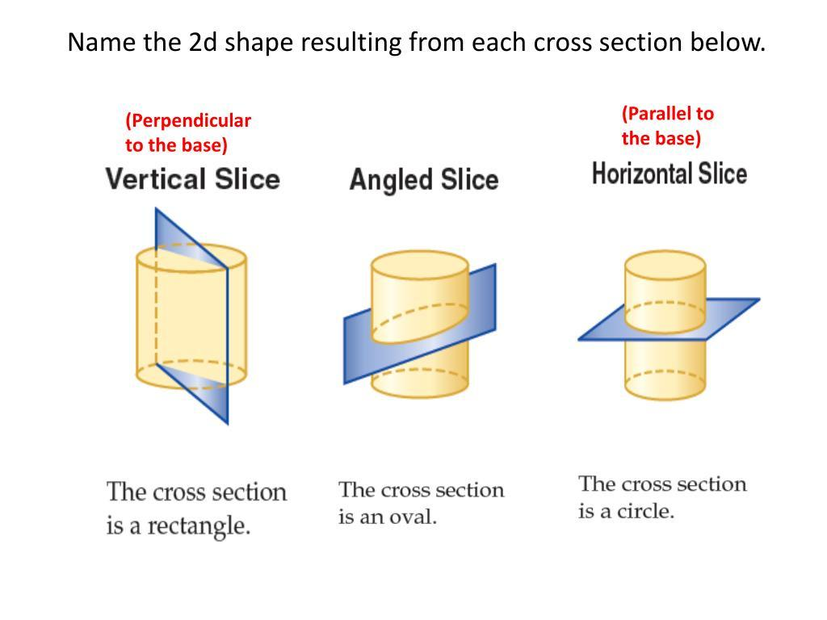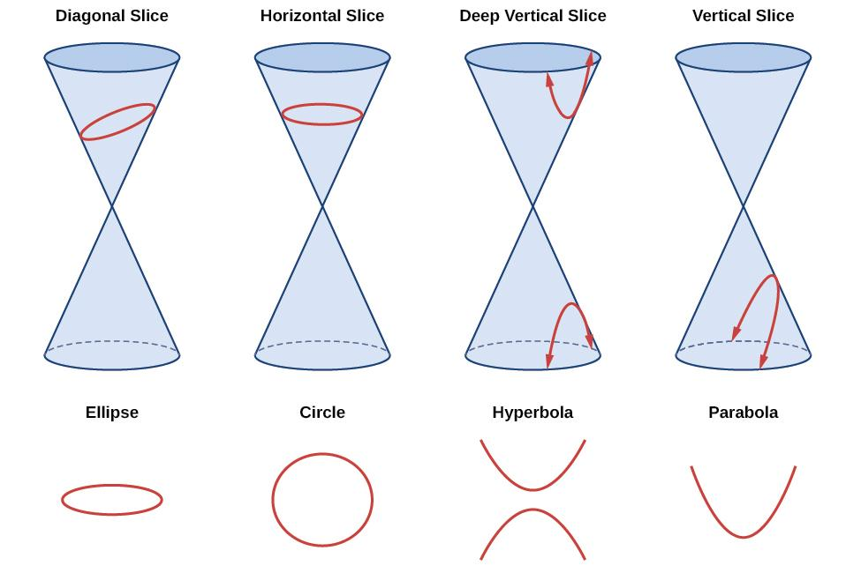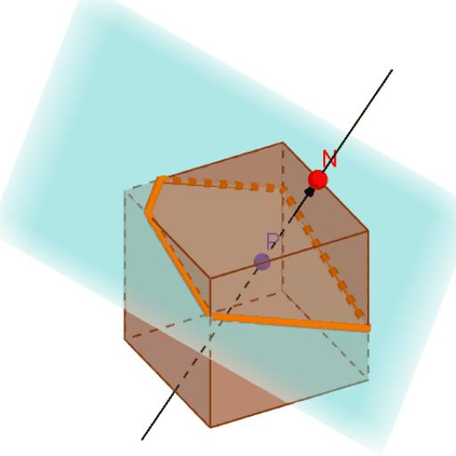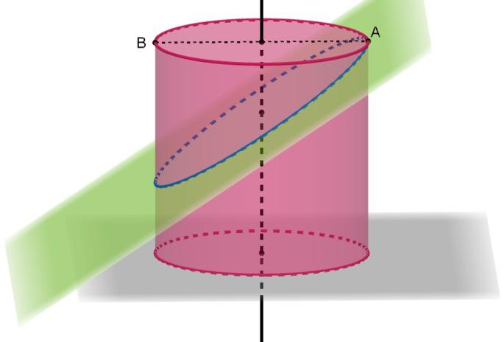
An Oblique Cross Section is formed when a solid is intersected by a plane that is inclined relative to its base.
Examples:
- Cylinder → Ellipse.
- Cone → Ellipse or another conic section, depending on the plane's position and inclination.
- Cube → Polygon.
- Sphere → Circle.

Tangential Cross Section
# Source: AI Source: Provided by: [Data Path: Persons Table -> ID Column: 1, Name_En Column: Motasem Essam] -> From: [ChatGPT] on [7/25/2026]
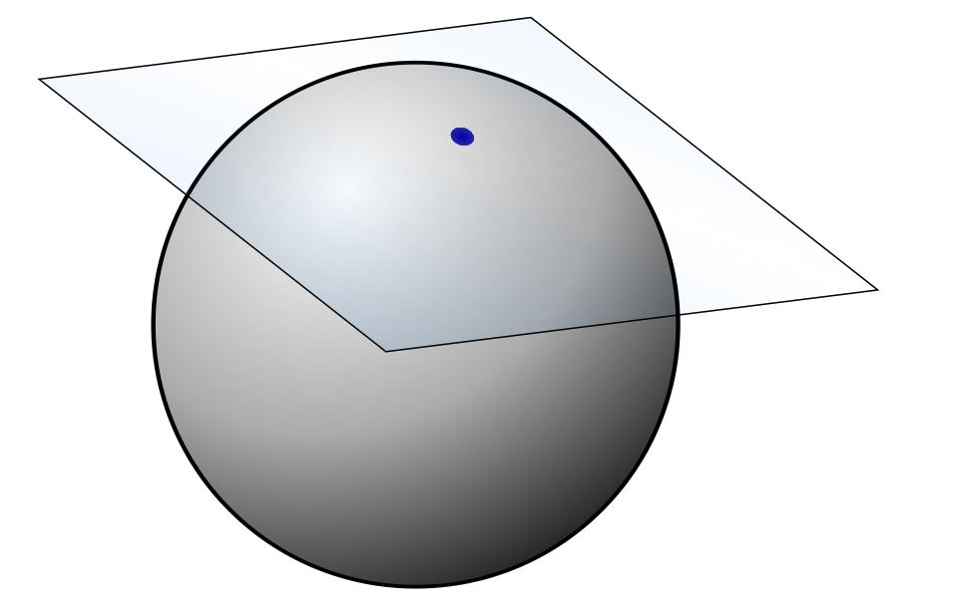
A Tangential Cross Section occurs when a plane touches a solid at its boundary without passing through its interior.
For a sphere, a tangent plane produces a single point rather than a two-dimensional cross-sectional region.
For a general solid, tangency may occur along a point, line, or other boundary portion.

Types of Cross Sections According to Geometric Shape
# Source: AI Source: Provided by: [Data Path: Persons Table -> ID Column: 1, Name_En Column: Motasem Essam] -> From: [ChatGPT] on [7/25/2026]
Cross-sections can also be classified according to the shape of the resulting two-dimensional figure.

Polygonal Cross Sections
# Source: AI Source: Provided by: [Data Path: Persons Table -> ID Column: 1, Name_En Column: Motasem Essam] -> From: [ChatGPT] on [7/25/2026]
A Polygonal Cross Section is a cross-section whose boundary consists entirely of straight line segments.
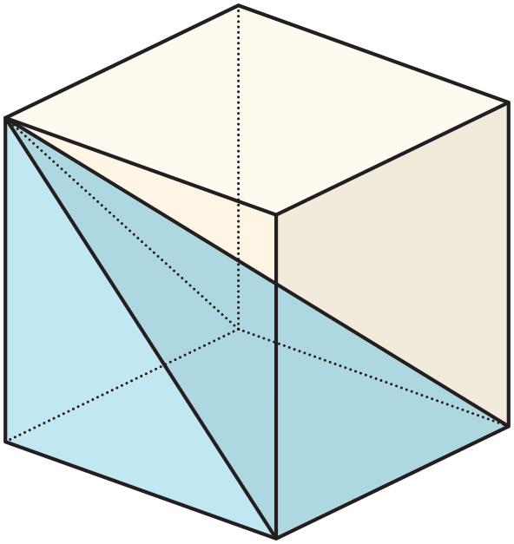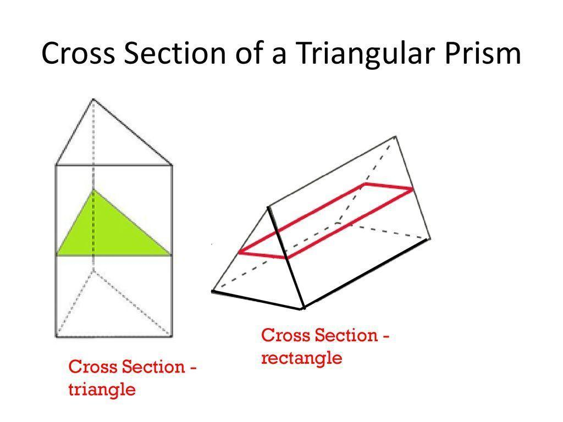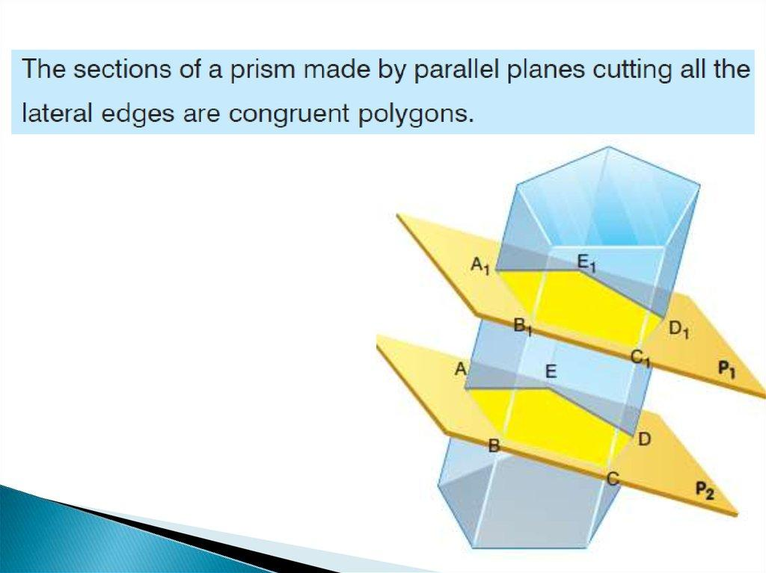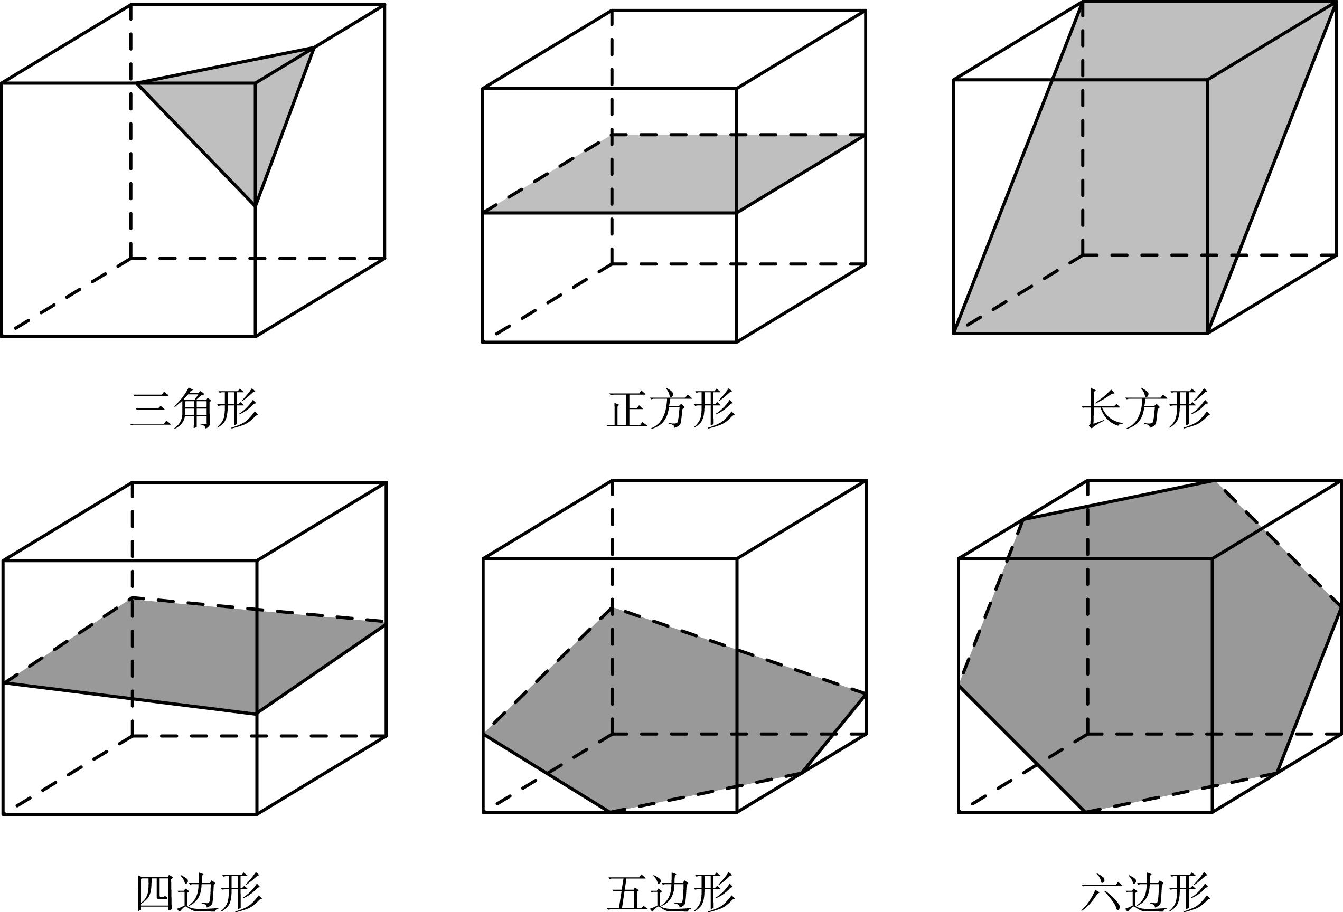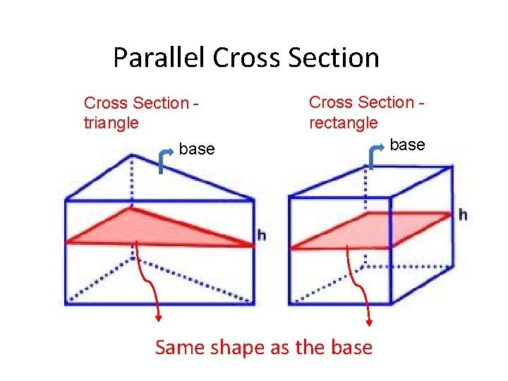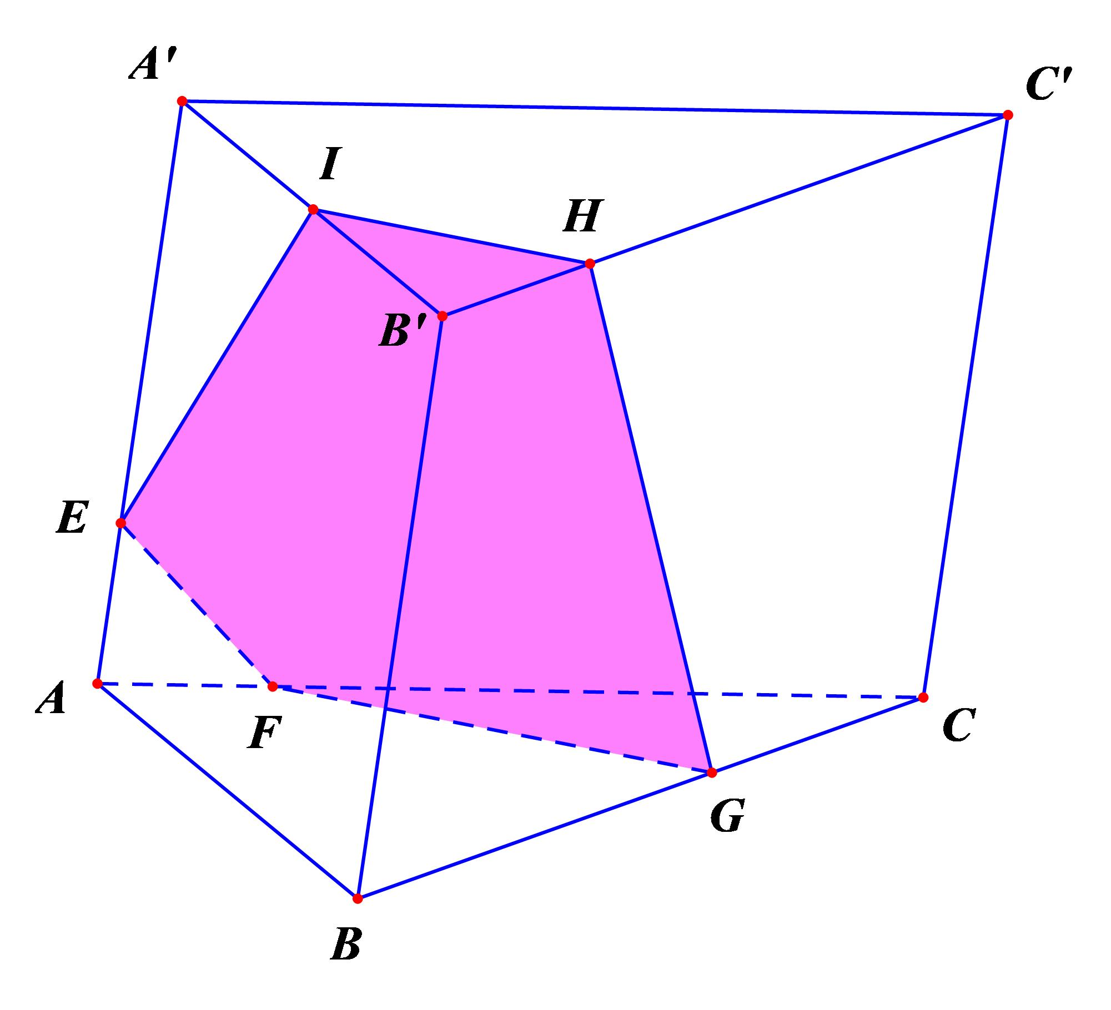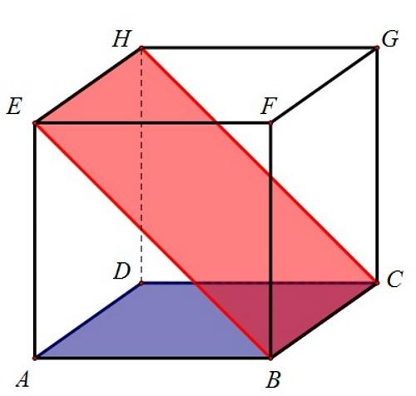
Types include:
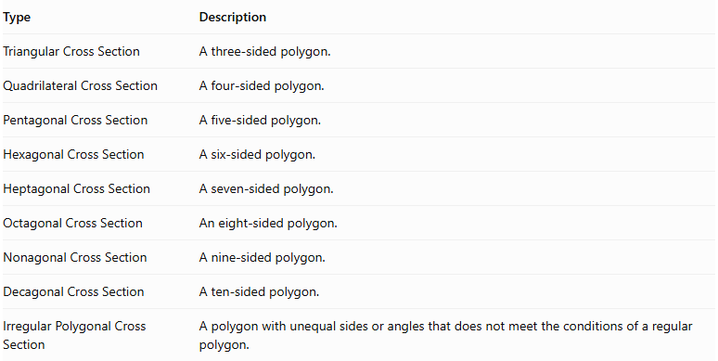
Type | Description
Triangular Cross Section | A three-sided polygon.
Quadrilateral Cross Section | A four-sided polygon.
Pentagonal Cross Section | A five-sided polygon.
Hexagonal Cross Section | A six-sided polygon.
Heptagonal Cross Section | A seven-sided polygon.
Octagonal Cross Section | An eight-sided polygon.
Nonagonal Cross Section | A nine-sided polygon.
Decagonal Cross Section | A ten-sided polygon.
Irregular Polygonal Cross Section | A polygon with unequal sides or angles that does not meet the conditions of a regular polygon.

Circular Cross Sections
# Source: AI Source: Provided by: [Data Path: Persons Table -> ID Column: 1, Name_En Column: Motasem Essam] -> From: [ChatGPT] on [7/25/2026]
A Circular Cross Section is a cross-section whose boundary is a circle.
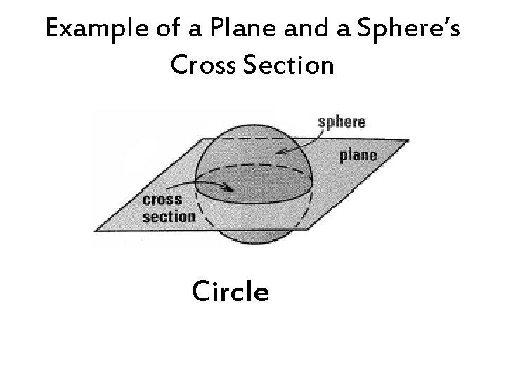
Examples:
- Sphere intersected by a plane.
- Cylinder intersected by a plane parallel to its base.
- Cone intersected by a plane parallel to its base.
- Torus intersected by certain planes.
The radius and area depend on the cutting position.
Circle area:
$$A=πr^{2}$$

Elliptical Cross Sections
# Source: AI Source: Provided by: [Data Path: Persons Table -> ID Column: 1, Name_En Column: Motasem Essam] -> From: [ChatGPT] on [7/25/2026]
An Elliptical Cross Section is a cross-section whose boundary forms an ellipse.
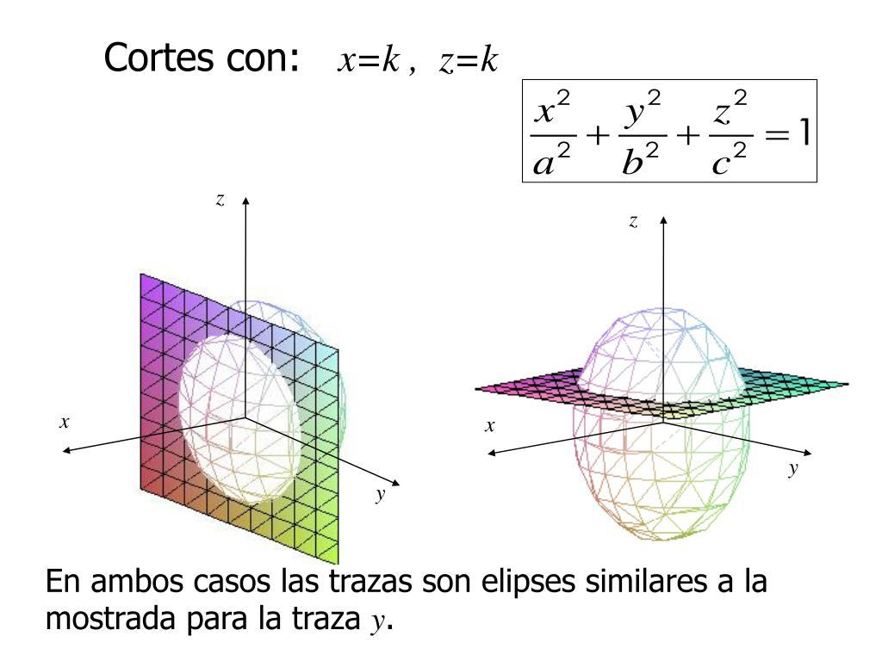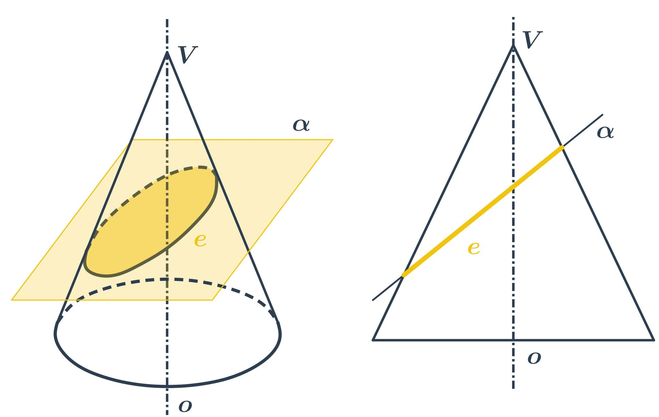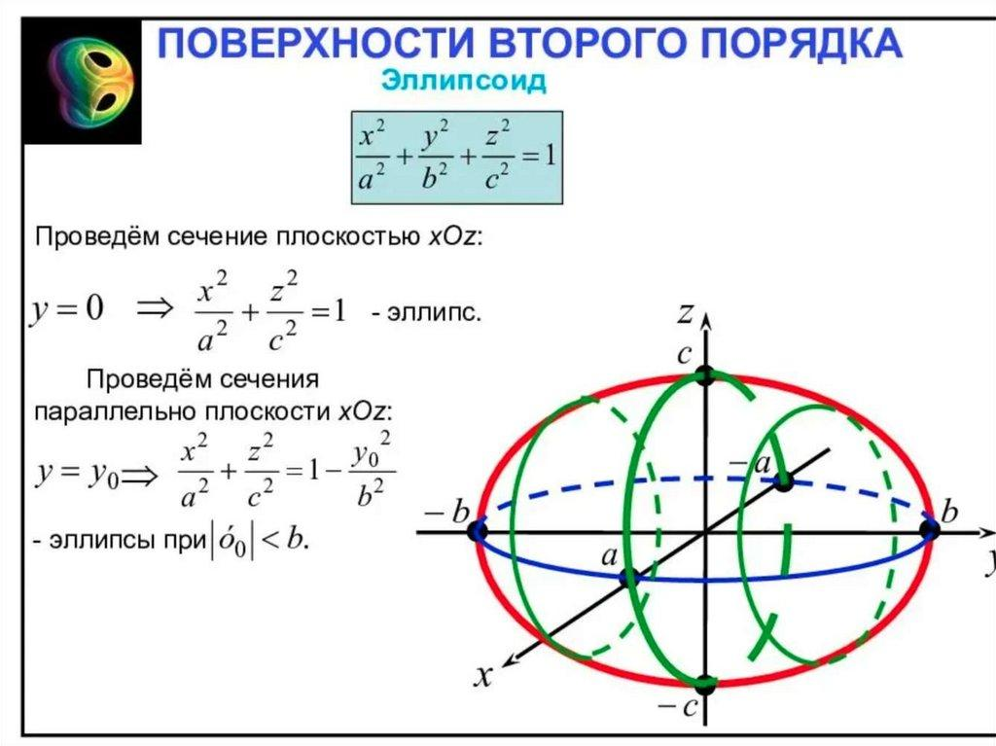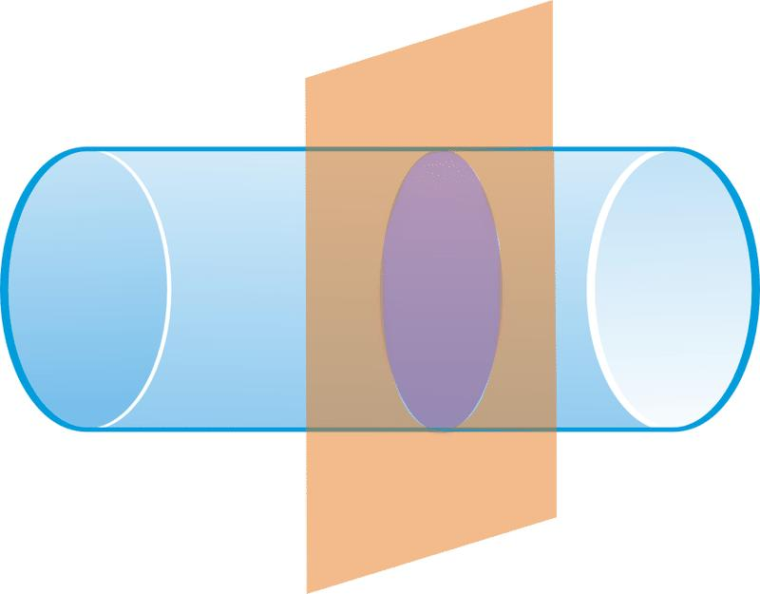
Examples:
- Cylinder intersected by an oblique plane that is not parallel to its axis.
- Cone intersected by a suitable oblique plane that does not pass through its apex.
- Ellipsoid intersected by a plane.
Ellipse area:
$$A=πab$$
Where:
- $a$ = semi-major axis.
- $b$ = semi-minor axis.

Annular Cross Sections
# Source: AI Source: Provided by: [Data Path: Persons Table -> ID Column: 1, Name_En Column: Motasem Essam] -> From: [ChatGPT] on [7/25/2026]
An Annular Cross Section is a cross-section shaped like a ring, consisting of the region between two concentric circles.
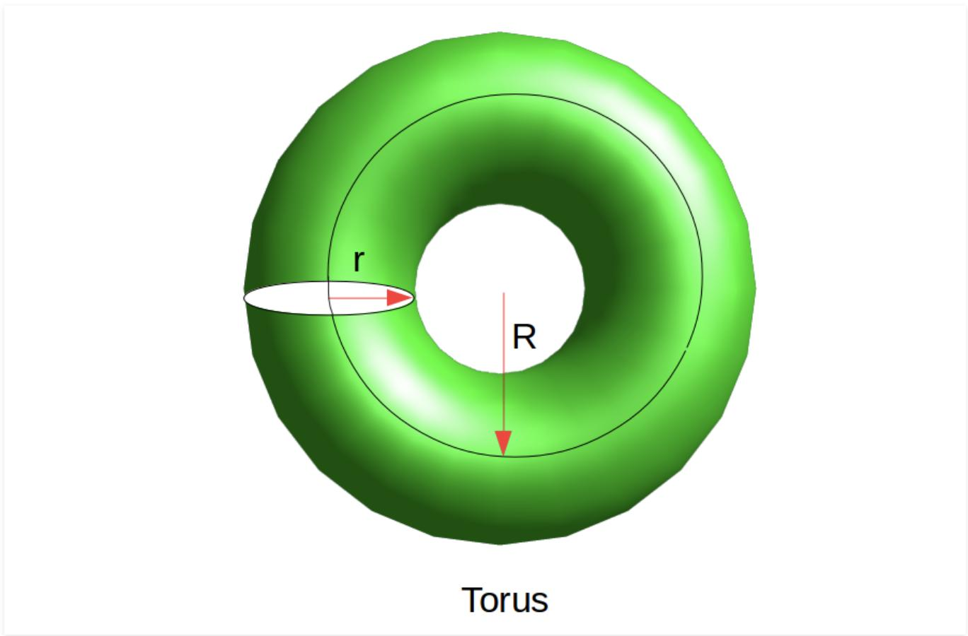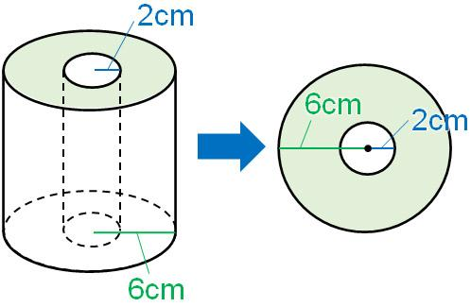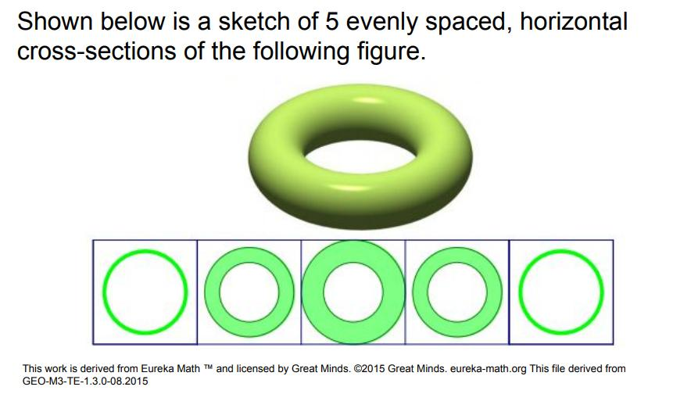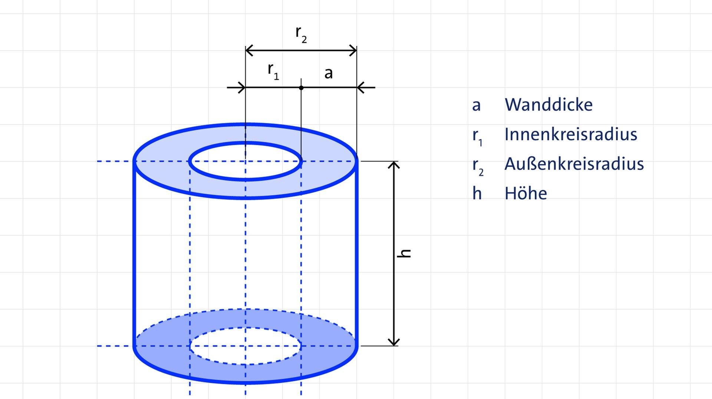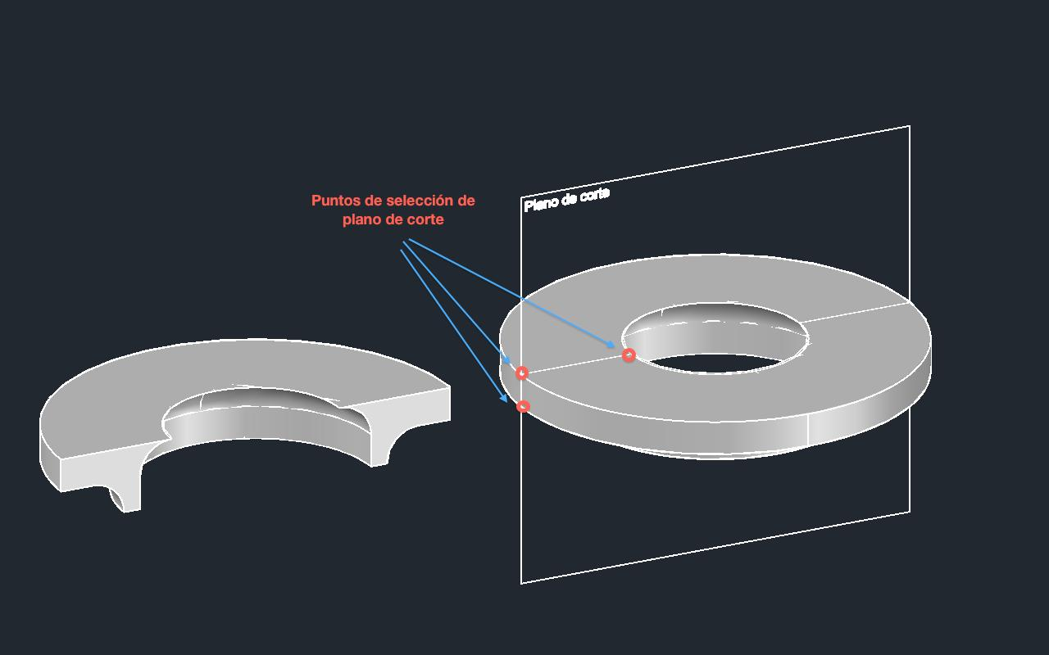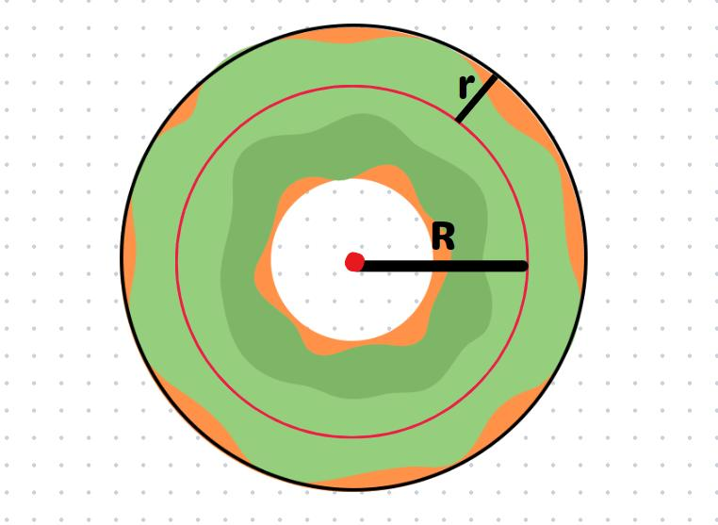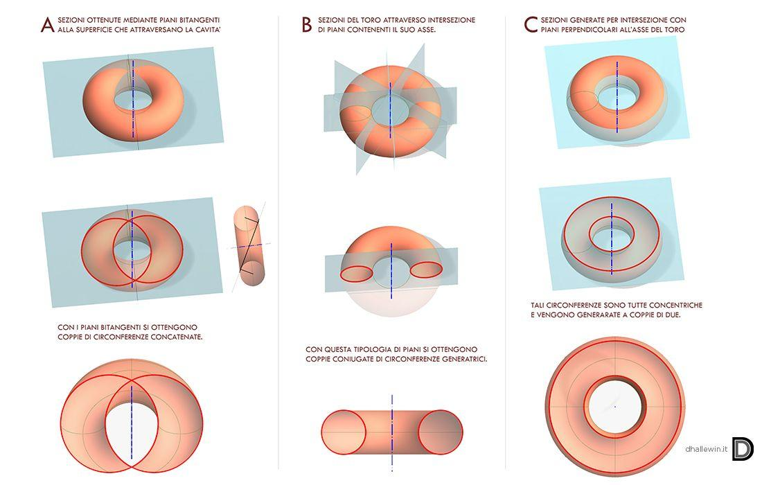
Examples:
- Hollow cylinder intersected by a plane perpendicular to its axis.
- Ring torus intersected by a suitable plane perpendicular to its axis.
Area:
$$A=π(R^{2}-r^{2})$$
Where:
- $R$ = outer radius.
- $r$ = inner radius.

Irregular Curvilinear Cross Sections
# Source: AI Source: Provided by: [Data Path: Persons Table -> ID Column: 1, Name_En Column: Motasem Essam] -> From: [ChatGPT] on [7/25/2026]
An Irregular Curvilinear Cross Section is a cross-section whose boundary includes curved portions that do not form a standard circle, ellipse, or other familiar conic section.
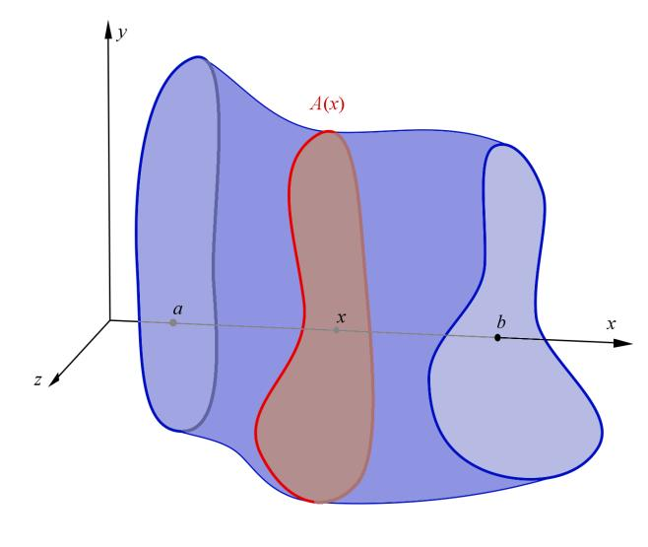
Examples include sections through:
- Irregular solids.
- Composite solids.
- Non-uniform solids of revolution.
- Complex curved surfaces.

Cross Sections of Common Geometric Solids
# Source: AI Source: Provided by: [Data Path: Persons Table -> ID Column: 1, Name_En Column: Motasem Essam] -> From: [ChatGPT] on [7/25/2026]
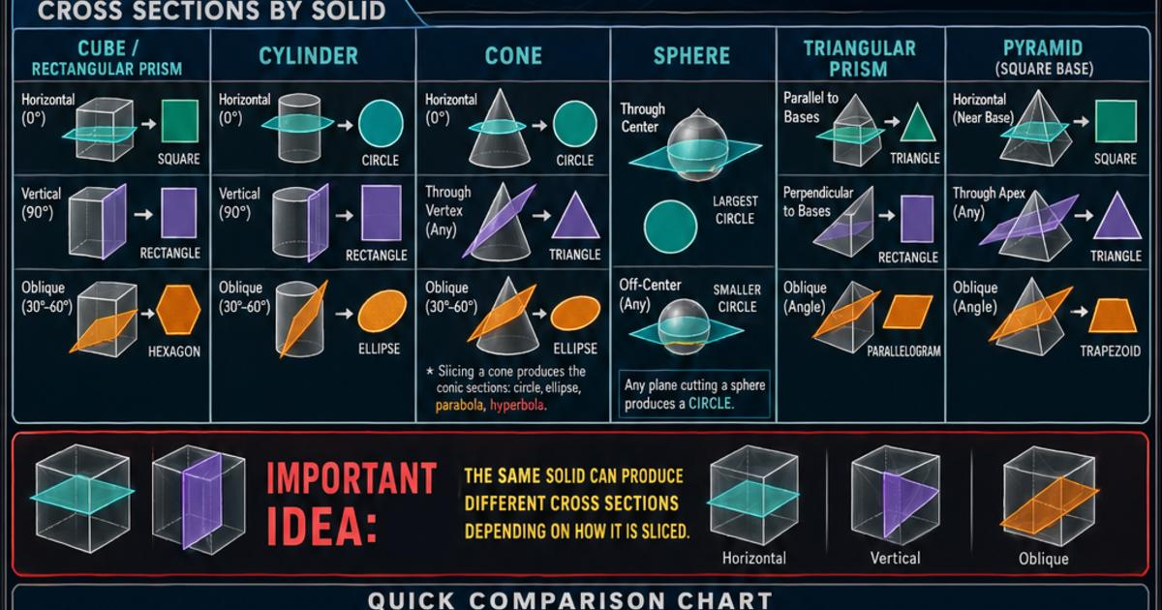
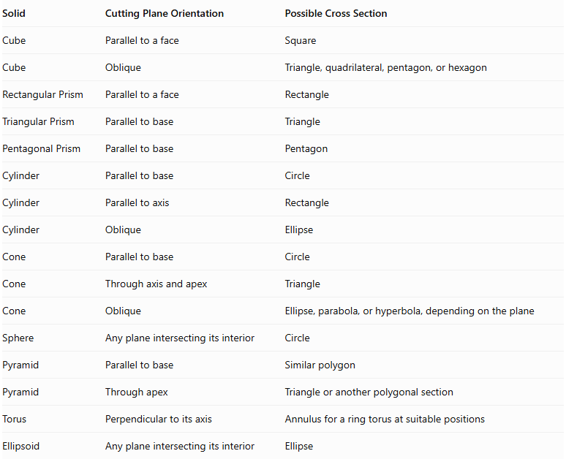
Solid | Cutting Plane Orientation | Possible Cross Section
Cube | Parallel to a face | Square
Cube | Oblique | Triangle, quadrilateral, pentagon, or hexagon
Rectangular Prism | Parallel to a face | Rectangle
Triangular Prism | Parallel to base | Triangle
Pentagonal Prism | Parallel to base | Pentagon
Cylinder | Parallel to base | Circle
Cylinder | Parallel to axis | Rectangle
Cylinder | Oblique | Ellipse
Cone | Parallel to base | Circle
Cone | Through axis and apex | Triangle
Cone | Oblique | Ellipse, parabola, or hyperbola, depending on the plane
Sphere | Any plane intersecting its interior | Circle
Pyramid | Parallel to base | Similar polygon
Pyramid | Through apex | Triangle or another polygonal section
Torus | Perpendicular to its axis | Annulus for a ring torus at suitable positions
Ellipsoid | Any plane intersecting its interior | Ellipse
Important: These are representative cases. A solid can produce additional cross-sectional shapes depending on the exact location and orientation of the plane.

Mathematical Representation

Plane Equation
# Source: AI Source: Provided by: [Data Path: Persons Table -> ID Column: 1, Name_En Column: Motasem Essam] -> From: [ChatGPT] on [7/25/2026]
A cutting plane in three-dimensional Cartesian coordinates can be represented by:
$$\boxed{ax+by+cz+d=0}$$
Where:
- $a,b,c$ determine the plane's normal vector.
- $d$ determines its position relative to the origin.
The normal vector is:
$$vecn=(a,b,c)$$

Cross-Section as an Intersection
# Source: AI Source: Provided by: [Data Path: Persons Table -> ID Column: 1, Name_En Column: Motasem Essam] -> From: [ChatGPT] on [7/25/2026]
If $S$ represents a solid and $P$ represents a plane, the cross-section is:
$$\boxed{C=S∩P}$$
Where:
- $C$ = cross-section.
- $S$ = three-dimensional solid.
- $P$ = cutting plane.

Cross-Sectional Area
# Source: AI Source: Provided by: [Data Path: Persons Table -> ID Column: 1, Name_En Column: Motasem Essam] -> From: [ChatGPT] on [7/25/2026]
The area of a cross-section depends on its geometric shape.
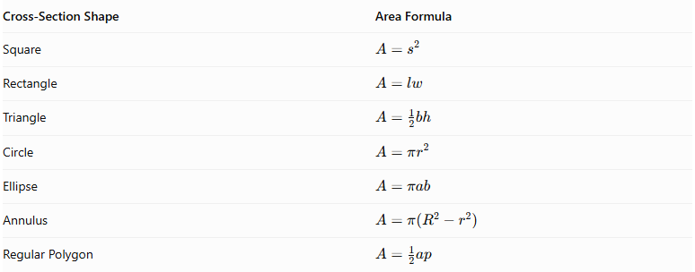
Cross-Section Shape | Area Formula
Square | $$A=s^{2}$$
Rectangle | $$A=lw$$
Triangle | $$A=\frac{1}{2}bh$$
Circle | $$A=πr^{2}$$
Ellipse | $$A=πab$$
Annulus | $$A=π(R^{2}-r^{2})$$
Regular Polygon | $$A=\frac{1}{2}ap$$
Where:
- $s$ = square side.
- $l,w$ = rectangle dimensions.
- $b,h$ = triangle base and height.
- $r$ = circle radius.
- $a,b$ = ellipse semi-axes.
- $R,r$ = annulus outer and inner radii.
- $a$ = polygon apothem.
- $p$ = polygon perimeter.

Cross Sections and Volume
# Source: AI Source: Provided by: [Data Path: Persons Table -> ID Column: 1, Name_En Column: Motasem Essam] -> From: [ChatGPT] on [7/25/2026]
Cross-sectional areas can be used to calculate the volume of a solid through integration.
$$\boxed{V=\int_{a}^{b}{A(x)} dx}$$
Where:
- $A(x)$ = area of the cross-section at position $x$.
- $a,b$ = limits along the chosen direction.
This method is known as the Method of Cross Sections or Slicing Method.

Special Geometric Principles

Cavalieri's Principle
# Source: AI Source: Provided by: [Data Path: Persons Table -> ID Column: 1, Name_En Column: Motasem Essam] -> From: [ChatGPT] on [7/25/2026]
Cavalieri's Principle states that if two solids have equal heights and equal cross-sectional areas at every corresponding position along parallel planes, then their volumes are equal.
$$A_{1}(x)=A_{2}(x)$$
For every corresponding position:
$$\boxed{V_{1}=V_{2}}$$
This principle provides a way to compare volumes without requiring the solids to have identical shapes.

Cross Sections of Prisms
# Source: AI Source: Provided by: [Data Path: Persons Table -> ID Column: 1, Name_En Column: Motasem Essam] -> From: [ChatGPT] on [7/25/2026]
For a prism, every cross-section parallel to its bases is congruent to the base.
$$A(x)=A_{\text{base}}$$
Therefore:
$$V=A_{\text{base}}h$$

Cross Sections of Pyramids
# Source: AI Source: Provided by: [Data Path: Persons Table -> ID Column: 1, Name_En Column: Motasem Essam] -> From: [ChatGPT] on [7/25/2026]
For a pyramid, cross-sections parallel to the base are similar to the base, but their dimensions decrease toward the apex.
If $h$ is the pyramid height and $x$ is the distance from the apex, then:
$$\frac{L_{x}}{L_{\text{base}}}=\frac{x}{h}$$
And the area ratio is:
$$\frac{A_{x}}{A_{\text{base}}}={\left(\frac{x}{h}\right)}^{2}$$

Applications
# Source: AI Source: Provided by: [Data Path: Persons Table -> ID Column: 1, Name_En Column: Motasem Essam] -> From: [ChatGPT] on [7/25/2026]
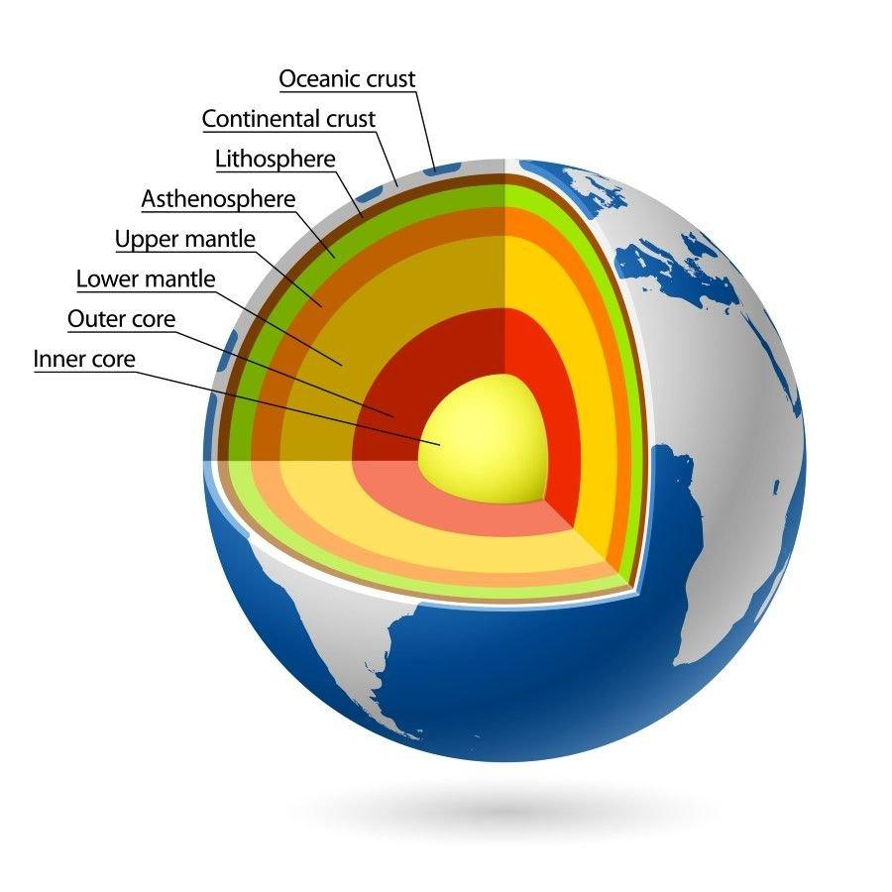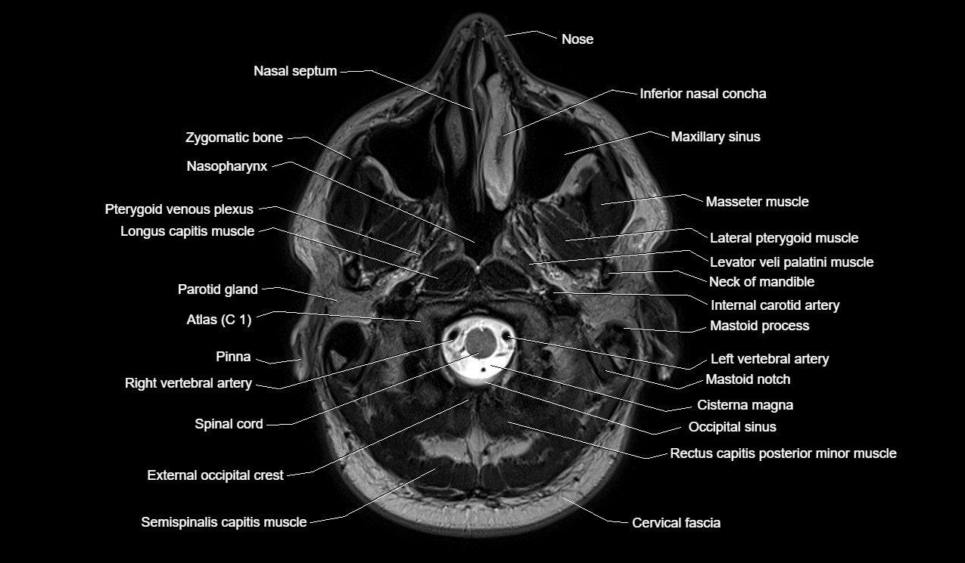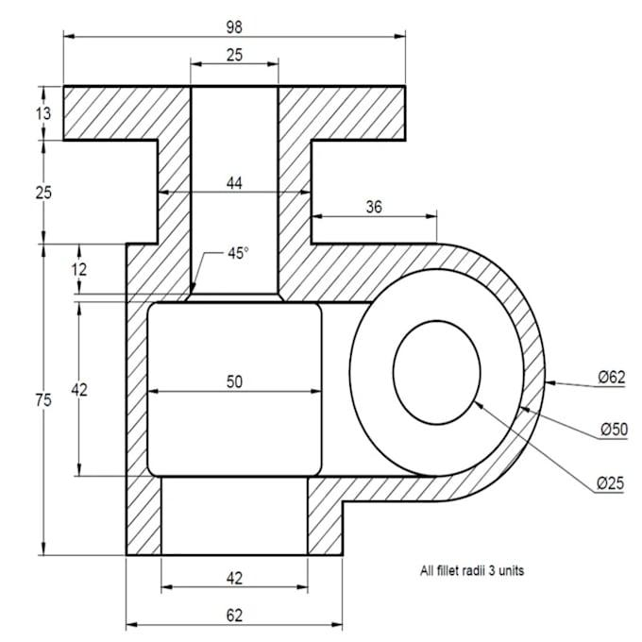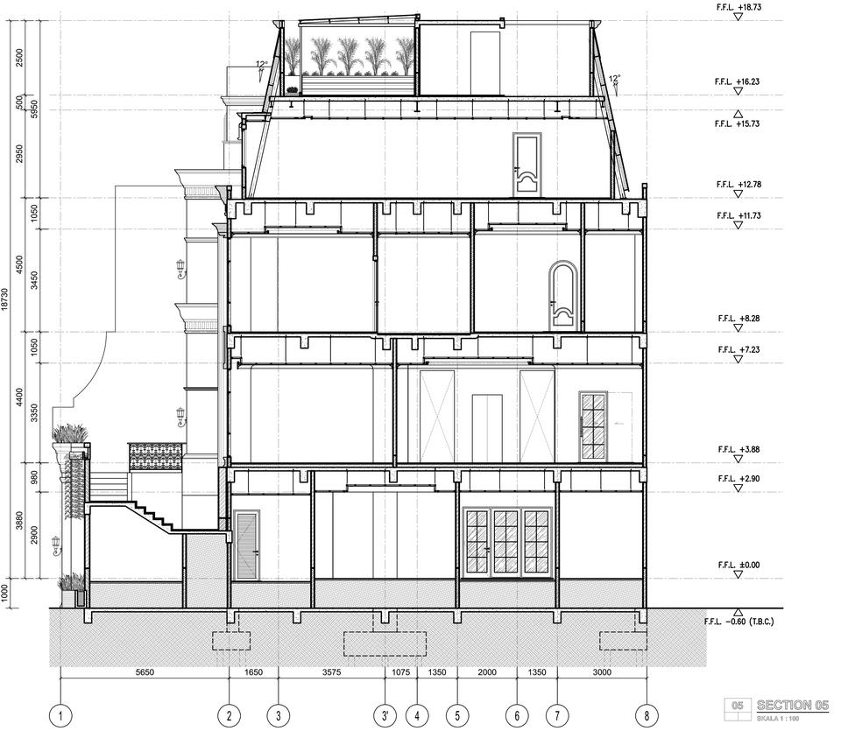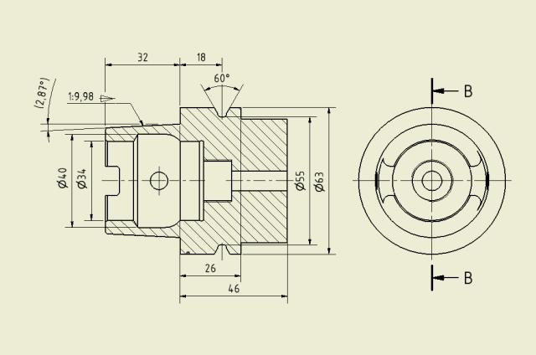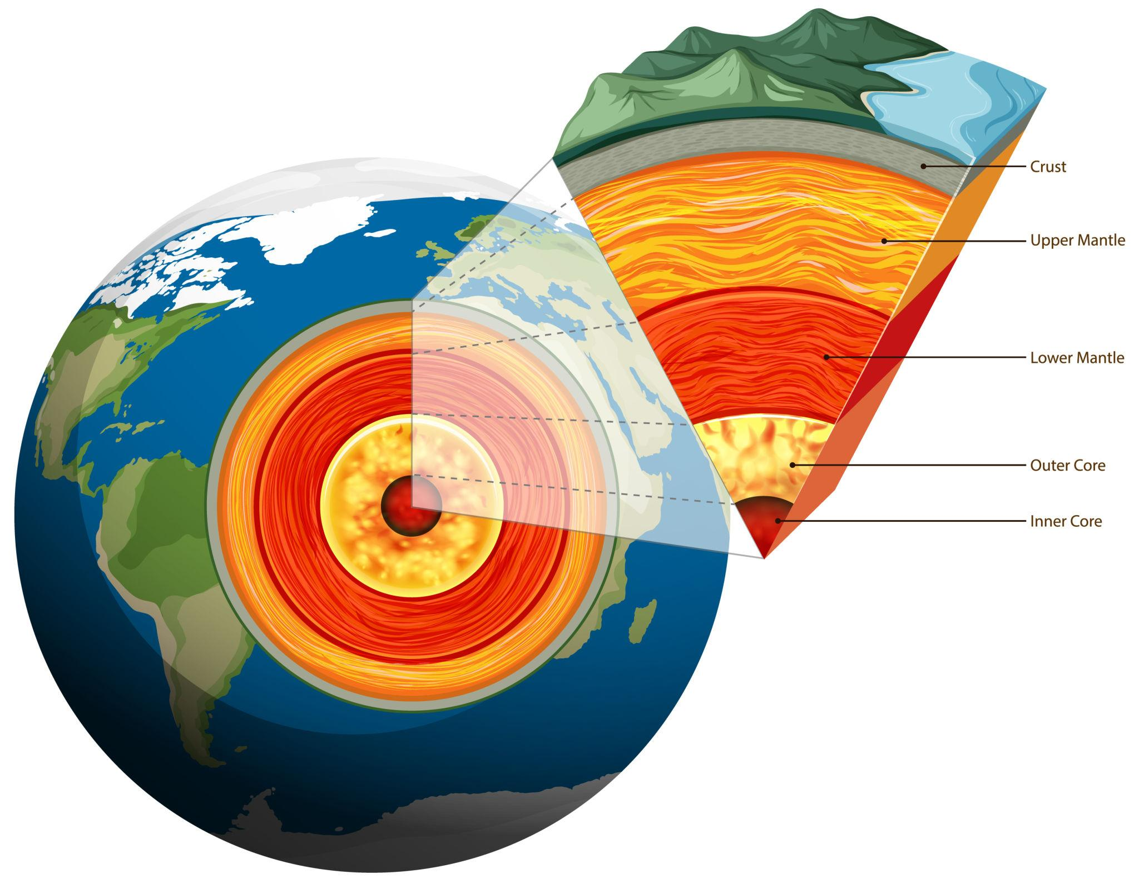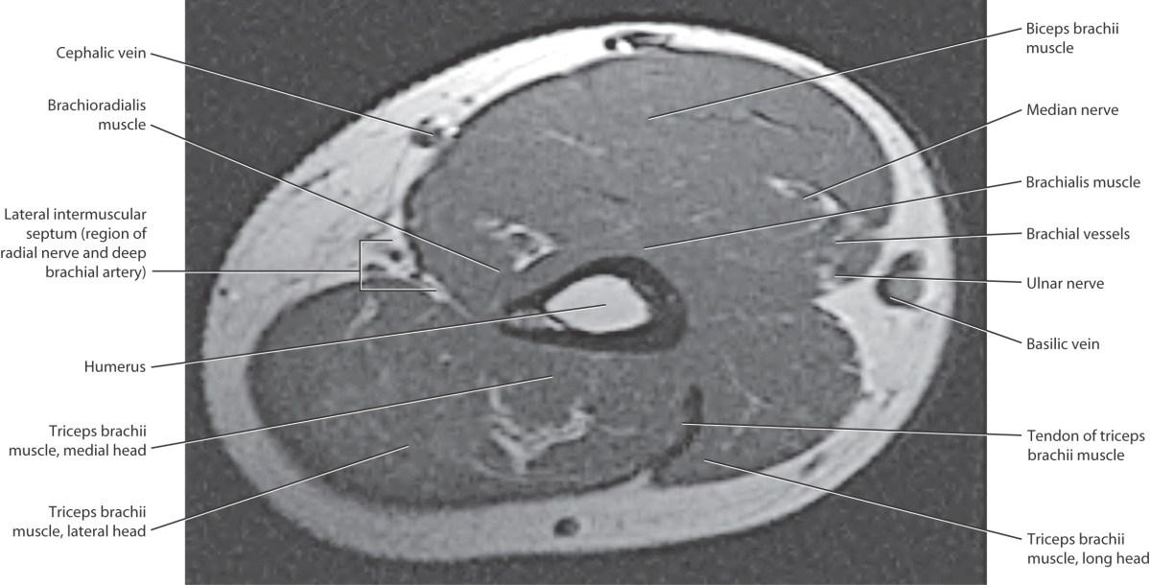
- Architecture: Examining internal building structures through sectional drawings.
- Mechanical Engineering: Studying internal components and hollow structures.
- Medicine: Producing sectional images using CT and MRI scanning.
- Geology: Studying underground layers and geological formations.
- Manufacturing: Inspecting the internal dimensions of manufactured components.
- Mathematics: Calculating volumes and analyzing three-dimensional shapes.

Main Classification
# Source: AI Source: Provided by: [Data Path: Persons Table -> ID Column: 1, Name_En Column: Motasem Essam] -> From: [ChatGPT] on [7/25/2026]
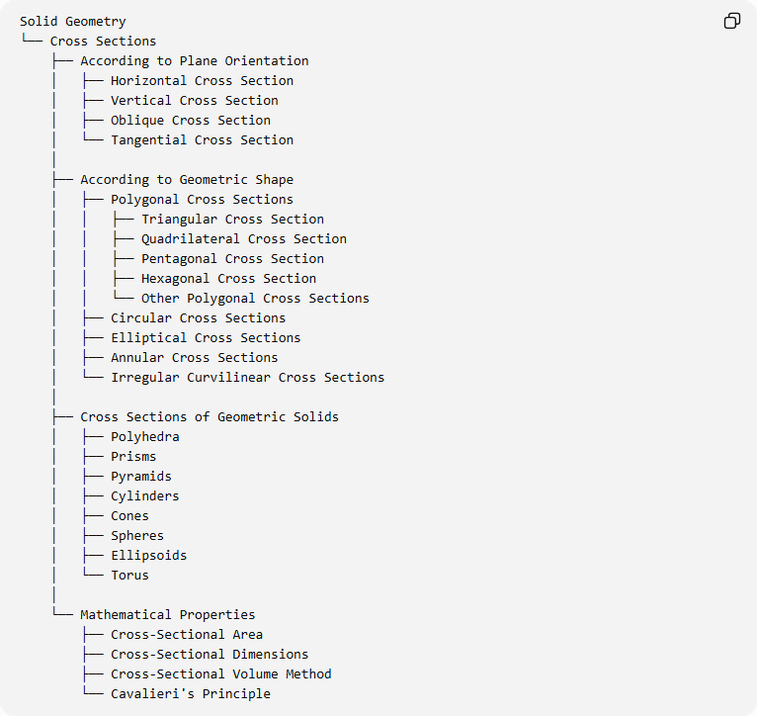
Solid Geometry
└── Cross Sections
├── According to Plane Orientation
│ ├── Horizontal Cross Section
│ ├── Vertical Cross Section
│ ├── Oblique Cross Section
│ └── Tangential Cross Section
│
├── According to Geometric Shape
│ ├── Polygonal Cross Sections
│ │ ├── Triangular Cross Section
│ │ ├── Quadrilateral Cross Section
│ │ ├── Pentagonal Cross Section
│ │ ├── Hexagonal Cross Section
│ │ └── Other Polygonal Cross Sections
│ ├── Circular Cross Sections
│ ├── Elliptical Cross Sections
│ ├── Annular Cross Sections
│ └── Irregular Curvilinear Cross Sections
│
├── Cross Sections of Geometric Solids
│ ├── Polyhedra
│ ├── Prisms
│ ├── Pyramids
│ ├── Cylinders
│ ├── Cones
│ ├── Spheres
│ ├── Ellipsoids
│ └── Torus
│
└── Mathematical Properties
├── Cross-Sectional Area
├── Cross-Sectional Dimensions
├── Cross-Sectional Volume Method
└── Cavalieri's Principle

Key Points
# Source: AI Source: Provided by: [Data Path: Persons Table -> ID Column: 1, Name_En Column: Motasem Essam] -> From: [ChatGPT] on [7/25/2026]
- A cross-section is the two-dimensional intersection of a solid and a plane.
- Its shape depends on the solid and the position and orientation of the cutting plane.
- Cross-sections can be polygonal, circular, elliptical, annular, or irregularly curved.
- Parallel cross-sections of prisms are congruent to their bases.
- Parallel cross-sections of pyramids are similar to their bases.
- The area of cross-sections can be used to calculate solid volumes.
- Cavalieri's Principle relates the areas of corresponding cross-sections to the volumes of solids.

Conclusion
# Source: AI Source: Provided by: [Data Path: Persons Table -> ID Column: 1, Name_En Column: Motasem Essam] -> From: [ChatGPT] on [7/25/2026]
Cross Sections are fundamental concepts in solid geometry because they provide a way to examine the internal two-dimensional structure of three-dimensional objects. By intersecting a solid with planes of different orientations and positions, various geometric shapes can be obtained.
Cross-sections are important for understanding the properties of polyhedra, curved solids, and solids of revolution. They also provide essential mathematical techniques for calculating volumes, analyzing geometric structures, and studying three-dimensional objects.

Sources
# Source: AI Source: Provided by: [Data Path: Persons Table -> ID Column: 1, Name_En Column: Motasem Essam] -> From: [ChatGPT] on [7/25/2026]
- Khan Academy – Solid Geometry Vocabulary and Cross Sections.
- Math Is Fun – Cross Sections.
- K12 LibreTexts – Cross-Sections and Nets.
- McGraw Hill – Representations of Three-Dimensional Figures.
- Minnesota State University – Cross Section Lesson.

